The DevOps team is working on automating file management between two S3 buckets. The task is to create a public S3 bucket for file uploads and a private S3 bucket for securely storing the files. A Lambda function will be triggered automatically whenever a file is uploaded to the public S3 bucket, which will copy the file to the private bucket. Additionally, logs of the operation will be stored in a DynamoDB table. The logs should include details such as the source bucket, destination bucket, and the object key of the file that was copied. This will help the team maintain better security and visibility for file transfers.
- Create a public S3 bucket named devops-public-23138. Ensure that the bucket allows public access to its objects.
- Create a private S3 bucket named devops-private-28397. Ensure that the bucket does not allow public access.
- Create a Lambda function named devops-copyfunction. This function should be triggered by uploads to the public S3 bucket and should copy the uploaded file to the private bucket. Create the necessary policies and a role named lambda_execution_role. Attach these policies to the role, and then link this role to the Lambda function.
- lambda-function.py is already present under the /root/ directory on AWS client host, replace REPLACE-WITH-YOUR-DYNAMODB-TABLE and REPLACE-WITH-YOUR-PRIVATE-BUCKET values.
- Create a DynamoDB table named devops-S3CopyLogs with a partition key LogID (string). This table will store logs generated by the Lambda function, including details such as source bucket name, destination bucket name, and object key.
- For testing upload the file sample.zip located in the /root directory on the client host to the public S3 bucket. The Lambda function should trigger and copy the file to the private bucket.
- Verify that the file has been successfully copied to the private bucket by checking the private bucket in the S3 console.
- Verify that a log entry has been created in the DynamoDB table containing the file copy details.

Use below given AWS Credentials: (You can run the showcreds command on aws-client host to retrieve these credentials)
Console URL | https://375398625824.signin.aws.amazon.com/console?region=us-east-1
Username | kk_labs_user_491556
Password | 7A!kVBi8!ZWC
Start Time | Wed Jan 14 10:31:14 UTC 2026
End Time | Wed Jan 14 11:31:14 UTC 2026
Notes:
- Create the resources only in us-east-1 region.
- To display or hide the terminal of the AWS client machine, you can use the expand toggle button as shown below:
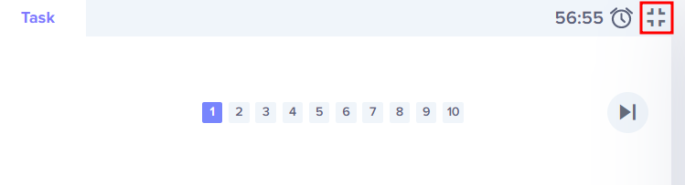

Solutions:-

S3 Buckets (us-east-1)
- devops-public-23138
  - Appears under S3 → Buckets.
  - Public access enabled with a bucket policy allowing s3:GetObject.
  - You’ll see uploaded files like sample.zip listed in the Objects tab.
- devops-private-28397
  - Also under S3 → Buckets.
  - Public access blocked (Public Access Block settings ON).
  - After Lambda runs, you’ll see sample.zip copied here.
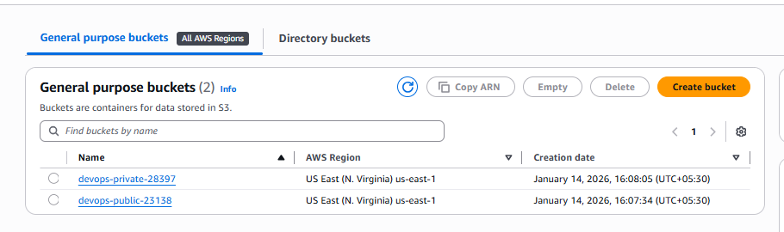
🔹 DynamoDB
- devops-S3CopyLogs
  - Found under DynamoDB → Tables.
  - Partition key: LogID (String).
  - In the Items view, each log entry shows:
    - Source bucket: devops-public-23138
    - Destination bucket: devops-private-28397
    - Object key: sample.zip

🔹 Step 6: Prepare Lambda Function
Edit /root/lambda-function.py:
- Replace:
  - REPLACE-WITH-YOUR-DYNAMODB-TABLE → devops-S3CopyLogs
  - REPLACE-WITH-YOUR-PRIVATE-BUCKET → devops-private-28397

  - Runtime: Python 3.9.
  - Linked IAM role: lambda_execution_role.
  - Triggers tab: shows S3 bucket devops-public-23138 with event type ObjectCreated:*.
  - Monitoring tab: CloudWatch logs for execution details.
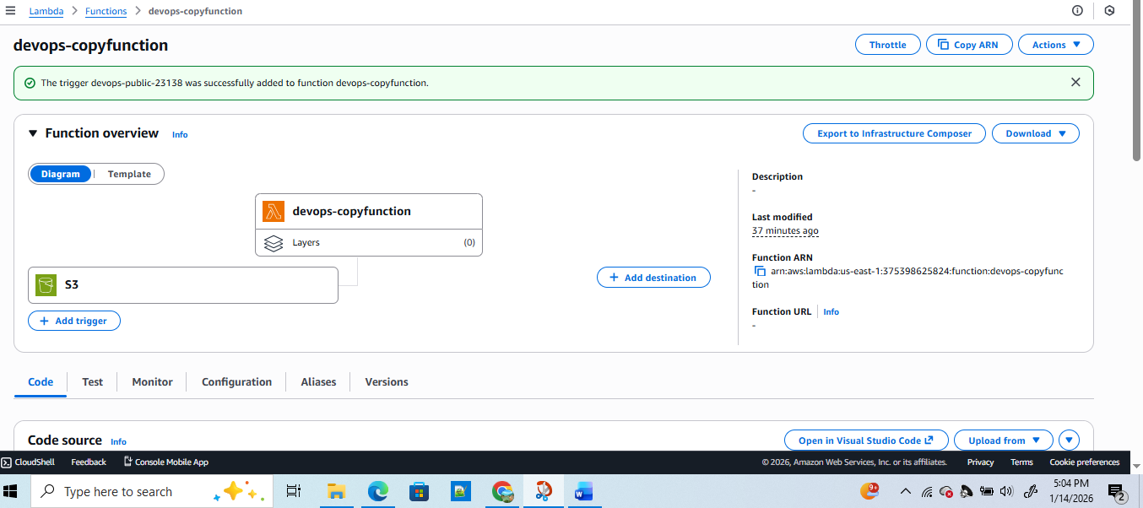
🔹 IAM
- lambda_execution_role
  - Found under IAM → Roles.
  - Attached policies:
    - AmazonS3FullAccess
    - AmazonDynamoDBFullAccess
    - AWSLambdaBasicExecutionRole

~ on ☁️ (us-east-1) ➜ aws s3 cp sample.zip s3://devops-public-23138

✅ So in the console, you’ll navigate like this:
- S3 → Buckets → verify file movement.
- DynamoDB → Tables → check logs.
- Lambda → Functions → confirm trigger and execution.
IAM → Roles → confirm permissions

